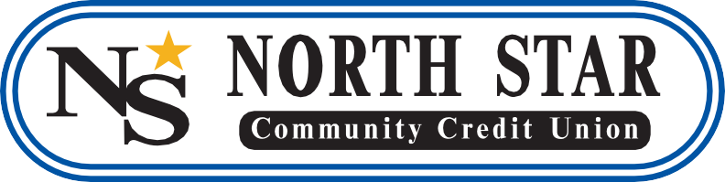

Lorna Kohn
Director of Business Development and Marketing
North Star Community Credit Union
l.kohn@nsccu.org
(712) 225-5731

FOR IMMEDIATE RELEASE:
Jeff Hayes Elected to the Iowa Credit Union League Board of Directors
CHEROKEE, Iowa – Jeff Hayes, President/CEO of North Star Community Credit Union, has been elected to serve on the Iowa Credit Union League (ICUL) Board of Directors for 2019-2020. By serving on the ICUL Board, Hayes represents the collective interests and future of Iowa's 86 credit unions and their more than 1.3 million members. ICUL is the trade association for Iowa's not-for-profit credit union industry.
"On behalf of the Iowa Credit Union League, I would like to congratulate Jeff on being selected to serve on ICUL’s Board of Directors," said Murray Williams, President and CEO, ICUL. “Jeff brings a wealth of knowledge and insight to the board and we sincerely appreciate his dedication to improving the financial lives of consumers and the credit union philosophy of people helping people. I look forward to working with him."
Hayes has been the President/CEO of North Star Community Credit Union for the past 15 years. Under his leadership, the credit union has grown its membership to over 11,000 and increased its asset size by 127 percent, surpassing the $100 million mark, this year. He was also nominated as one of the Credit Union National Associations (CUNA) Hero of the Year in 2018 and helps to develop up-and-coming credit union leaders from all over the country at CUNA Management School in Madison, Wisconsin.
“It’s an honor to be elected to serve on ICUL’s Board of Directors,” said Hayes. “I believe strongly in the credit union industry and look forward to working with other Iowa credit union leaders to develop initiatives that will help improve the financial lives of our members and their families and advance the credit union movement.”
About North Star Community Credit Union
North Star Community Credit Union has locations in Cherokee, Ida Grove and Sheldon, Iowa. Our membership of over 11,000, represents 14 counties in Northwest Iowa and our assets exceed $103 million. For more information visit nsccu.org. Federally insured by NCUA.
About the Iowa Credit Union League
The Iowa Credit Union League is the trade association that represents the interests of Iowa credit unions and their more than one million members. Credit unions are not-for-profit, financial cooperatives owned and operated by their members. Iowans use their credit union membership to receive higher interest rates on savings and lower interest rates on loans. For more information on ICUL and Iowa credit unions, visit www.IowaCreditUnions.com. Follow ICUL on Twitter at www.twitter.com/icul or on Facebook at www.facebook.com/iowacreditunions.

